DAY 6

CLASS EXERCISE 2

 @PostMapping("/api/student")

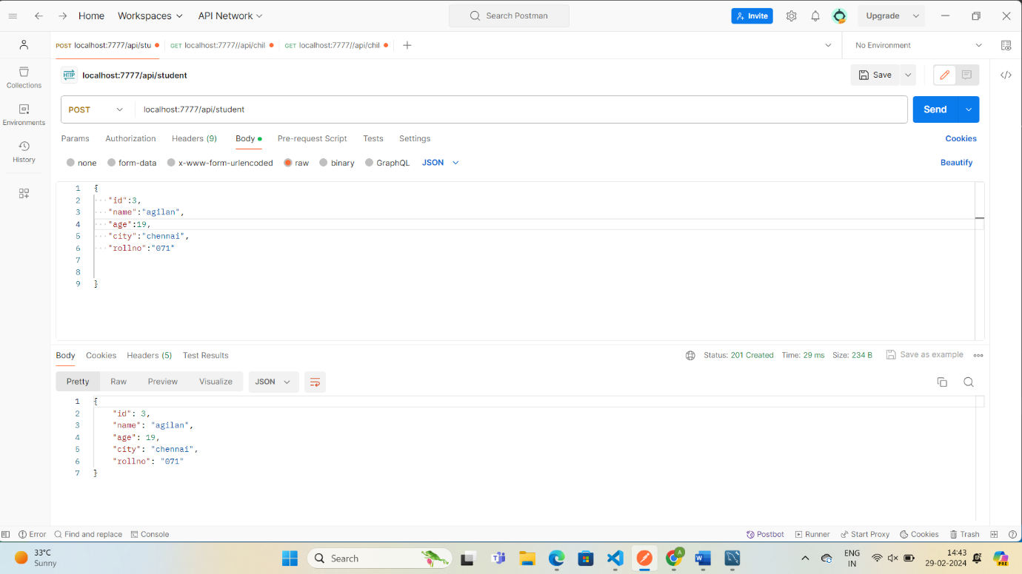

@GetMapping("/api/student")

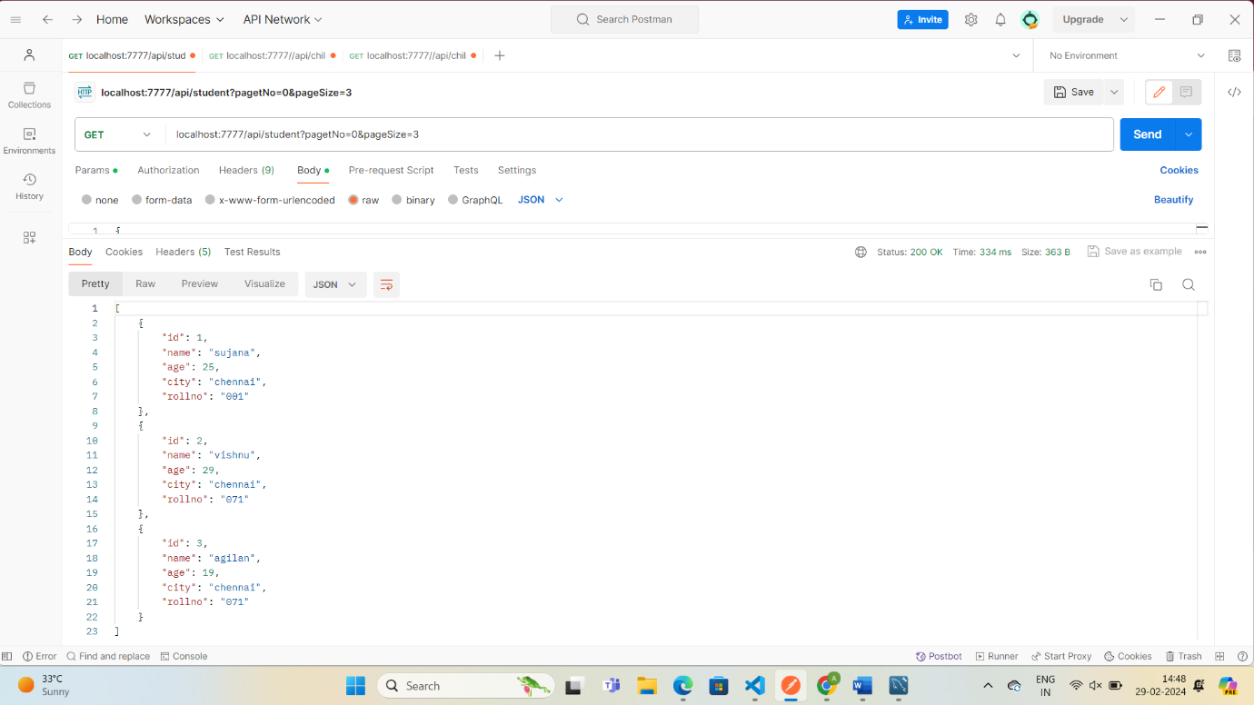

 @GetMapping("/api/student/sort")

